|  |
| --- |
| Proposal for  LANTAU LOCAL BIKE SHOP  By bikers, for bikers. |
| LOW, Zhi Hao, EugeneC:\temp\mountain-trail-sport-bicycle-bike-mountain-range-vehicle-extreme-sport-sports-equipment-mountain-bike-cycling-sports-downhill-freeride-mountain-biking-transalp-road-cycling-land-vehicle-cycle-sport-downhill-mountain-biking-mountain-bike.jpg City University of Hong Kong  GE2257 |

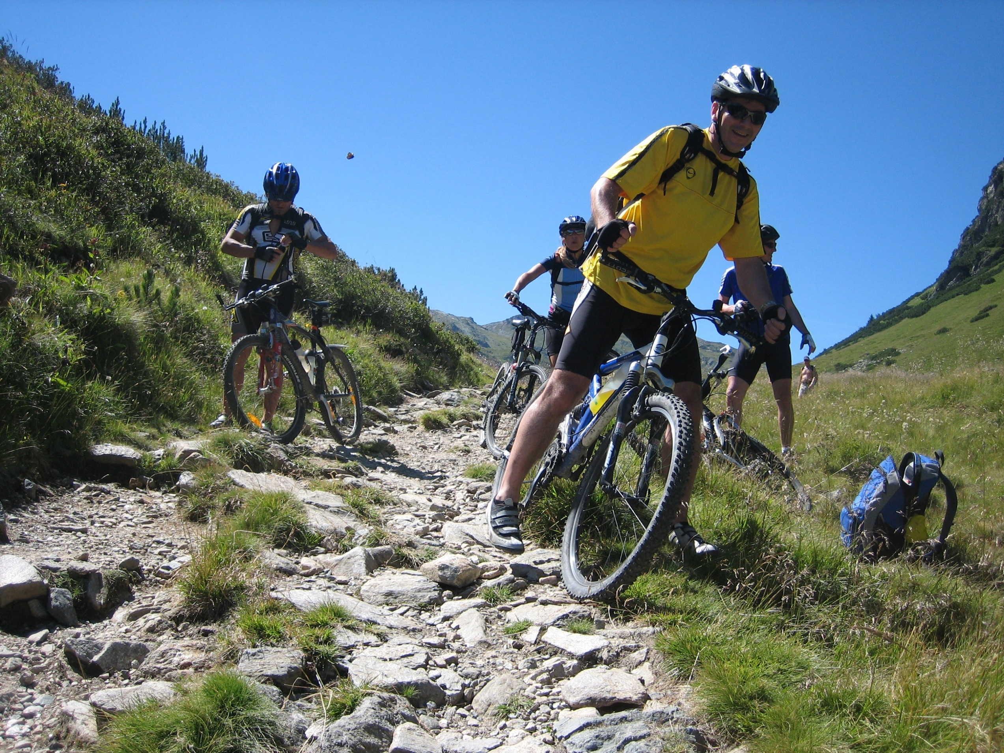



## The Project

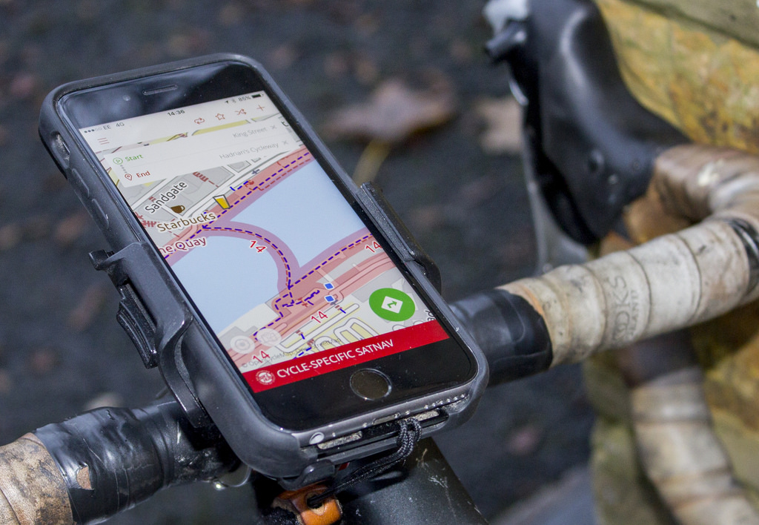

### Solution : Mobile Application

### ”Lantau Bike Shop”

### Rise of Mobile App

With the rise of mobile technology and smart phones, the most optimal solution to reach hundreds and millions of users is by implementing mobile application into current business.

This mobile application will fulfill the needs of the bikers in terms of the service we will provide and the products that we will market.

### **Our SOLUTION**

### **We want to create an app to provide service for bikers and utilize it as a platform for the products.**

# Navigation

### To switch between tabs.

### C:\Users\zhlow2\AppData\Local\Microsoft\Windows\INetCache\Content.Word\Screenshot_20180318-185957.png

#### User can switch between tabs to go to other service and products

# Location

### Showing location of Lantau Bike Shop and hotspot for biking.

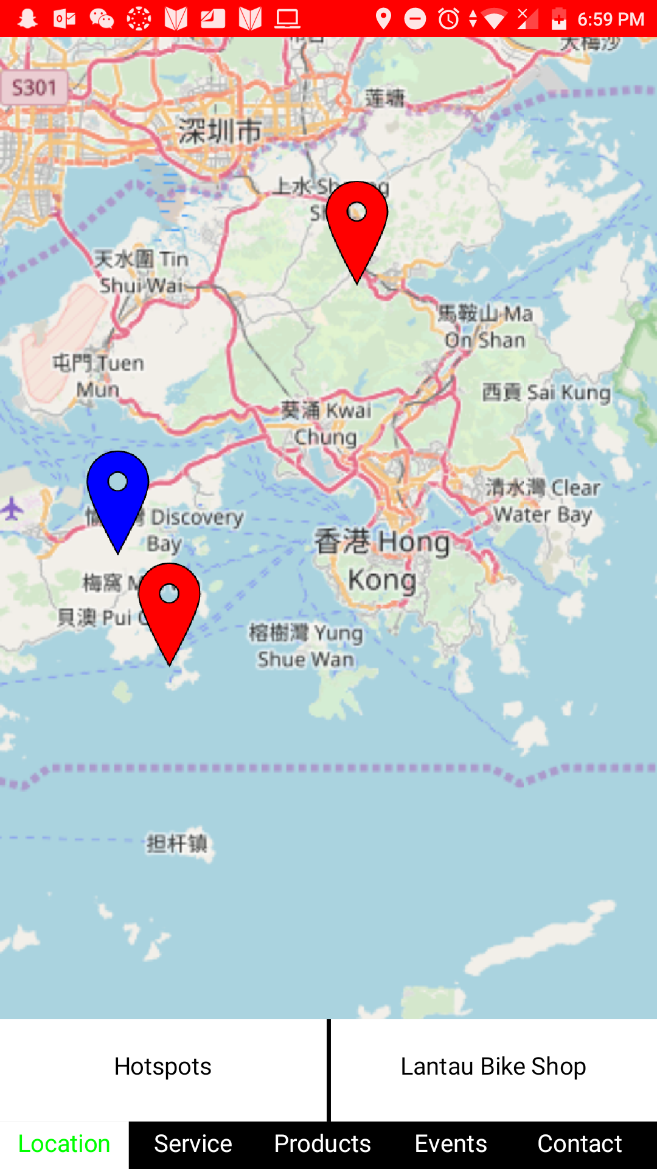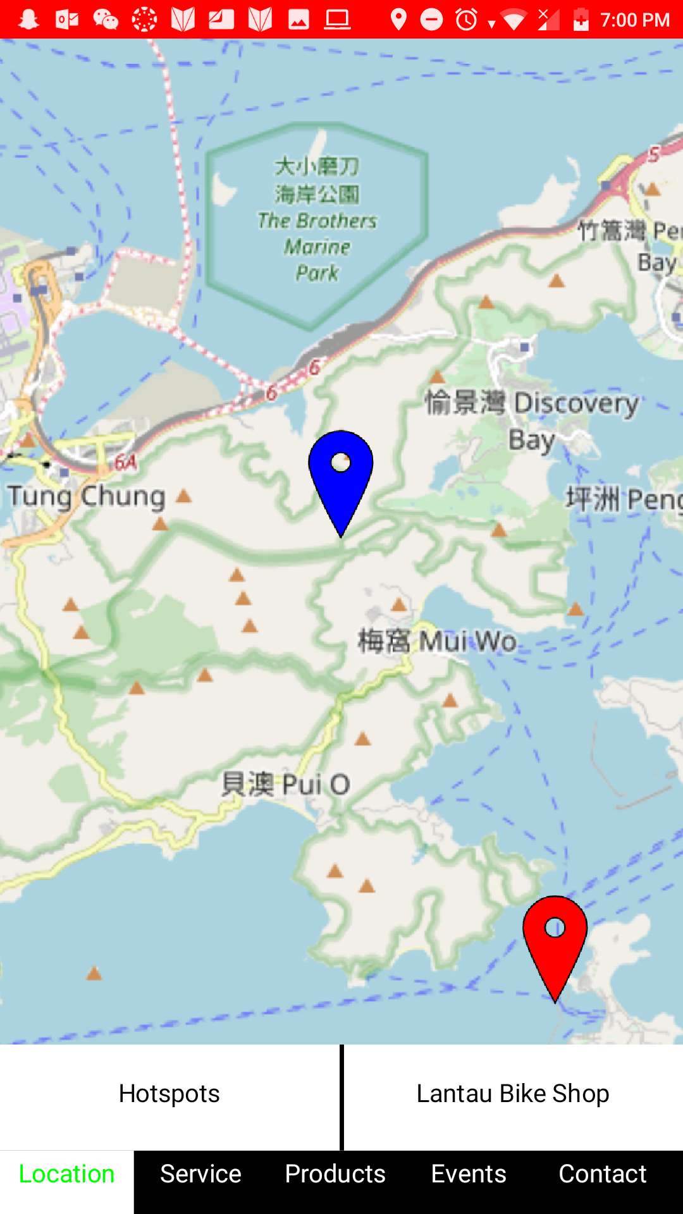

### C:\Users\zhlow2\AppData\Local\Microsoft\Windows\INetCache\Content.Word\Screenshot_20180318-190014.pngUser can select hot spots which will give them some suggestion of the “hotspot” for cycling.

### User can also click Lantau Bike Shop to forward them directly to the location of the shop. With blue marker.

# Service

### Providing service for repairing, rental and parking.

### **C:\Users\zhlow2\AppData\Local\Microsoft\Windows\INetCache\Content.Word\Screenshot_20180318-194456.pngC:\Users\zhlow2\AppData\Local\Microsoft\Windows\INetCache\Content.Word\Screenshot_20180318-194924.png**<<

### Rental: to rent a bike by bicycle type, date, time and duration.

### Repair: providing repair services for specific problem also showing the availability of the parts to be repaired.

### >>

### **C:\Users\zhlow2\AppData\Local\Microsoft\Windows\INetCache\Content.Word\Screenshot_20180318-193633.pngC:\Users\zhlow2\AppData\Local\Microsoft\Windows\INetCache\Content.Word\Screenshot_20180318-194140.png**<<

### Trainer: courses and time can be assigned for student to train.

### Cleaning: providing cleaning services, and lubricant services to maintain the bike quality.

### >>

# Products

### Marketing of first and second-hand bicycle.

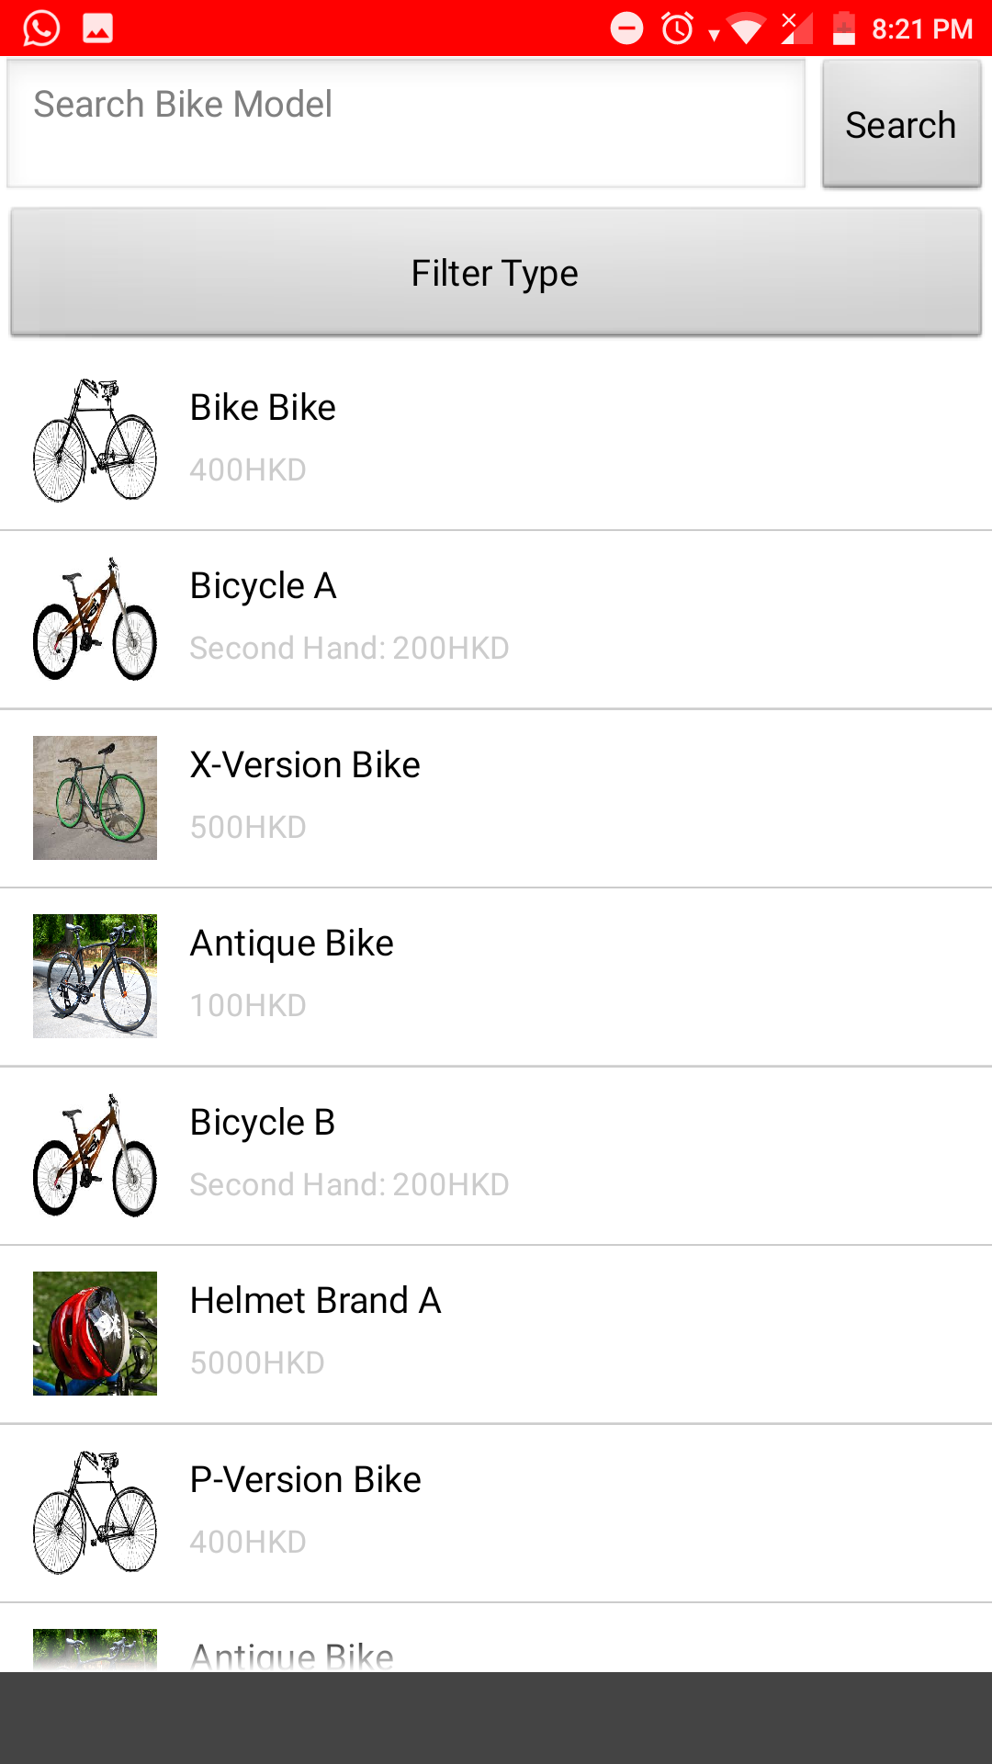

### Buying of bicycle made easy.

### Customer can search through bicycle and obtain bicycle information easily.

### 

# Events

### Showing nearby cycling events. Building a community.

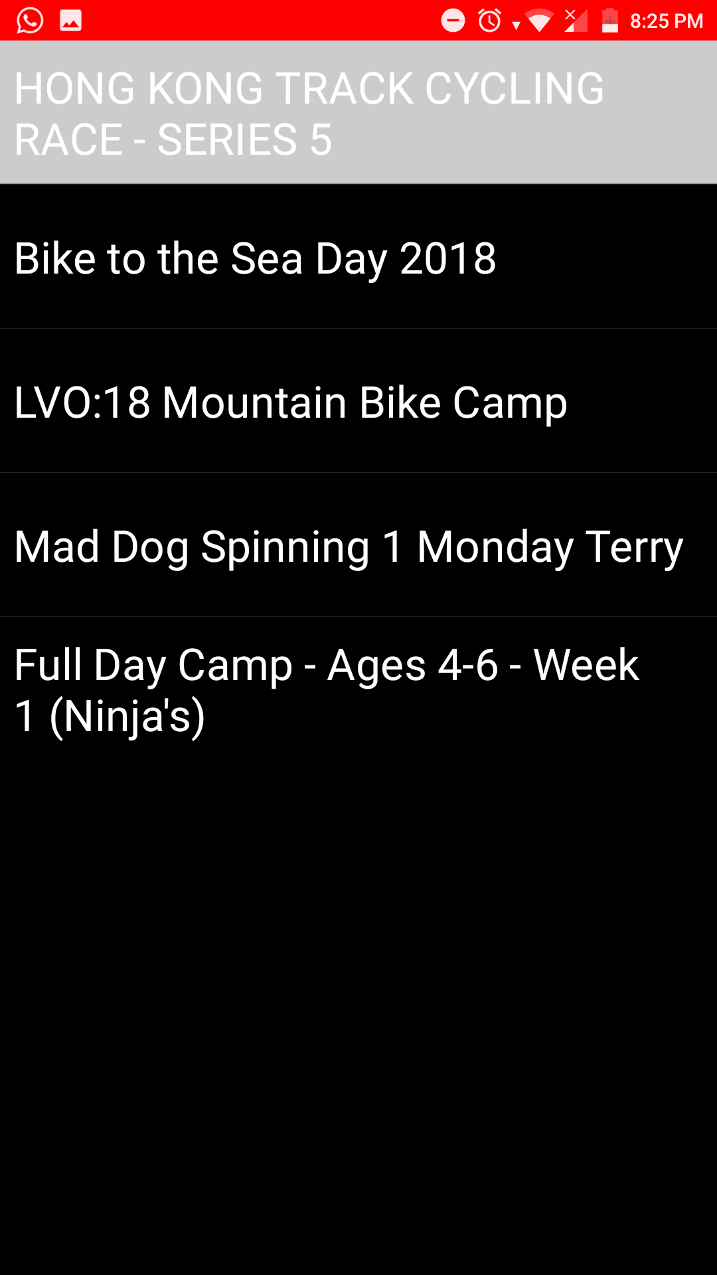

### Building relationship with your customers through events conducted by other community.

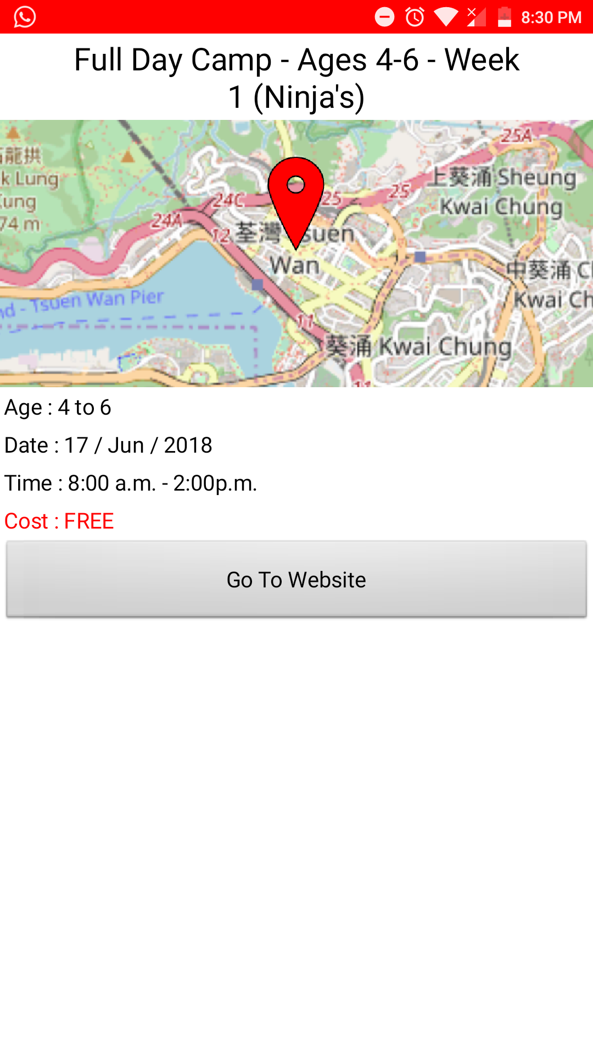

### Can be considered as a free advertisement platform.

### **Contact**

### Showing information of the shop for contact purposes.

# The Rivals

### Sunny Bike Shop 大嶼山單車店 – Website. http://www.sunnybike.com.hk/index.html

### Limitation :

#### Web application have limited functionality.

#### No event tab or section to gain regular customers.

### Bull Bike 野牛单车 – Website.

### http://bullbike.com.hk/

### Limitation :

#### Web application have limited functionality.

#### Doesn’t provide service for customers.

# The Prospects

### We expected in the future, Lantau Bike Shop can expands its reputation to all places in Hong Kong. Since Hong Kong have a immense market in cycling and hiking, Lantau Bike Shop application will sooner or later become the number one trading app for all the bikers.